**Experiment 4**

**Student Name: jitesh Kumar UID: 20BCS2334**

**Branch: CSE Section/Group: 903- A**

**Semester: 5th Date of Performance: 21/09/2022**

**Subject Name: Machine Learning Lab Subject Code: 20CSP-317**

1. **Aim/Overview of the practical:**

Implement Support Vector Machine on any data set and analyse the accuracy with Logistic regression

1. **Code and Output:**

**#SVM Implementation**

**#Harsh Pratap Singh**

**#20BCS5370**

**import pandas as pd**

**df = pd.read_csv("E:\\Sem 5\\Machine Learning Lab\\Exp 4\\appleorange.csv")**

**x = df.iloc[:,:2]**

**y = df.iloc[:,2]**

**from sklearn.model_selection import train_test_split**

**x_train, x_test, y_train, y_test = train_test_split(x,y, test_size=0.3, random_state=42)**

**from sklearn import svm**

**clf = svm.SVC(kernel = 'linear')**

**clf.fit(x_train, y_train)**

**y_pred = clf.predict(x_test)**

**y_pred**

**y_test**

**clf.score(x_test,y_test)**

**#Analysis using Logistic Regression**

**import pandas as pd**

**from matplotlib import pyplot as plt**

**df = pd.read_csv("E:\\Sem 5\\Machine Learning Lab\\Exp 4\\appleorange.csv")**

**df.head()**

**x = df[['size']]**

**y = df['class']**

**plt.scatter(x,y,marker='+',color='red')**

**from sklearn.model_selection import train_test_split**

**x_train, x_test, y_train, y_test = train_test_split(x,y,test_size=0.4)**

**x_test**

**from sklearn.linear_model import LogisticRegression**

**model = LogisticRegression()**

**model.fit(x_train, y_train)**

**y_predicted = model.predict(x_test)**

**y_predicted**

**model.predict_proba(x_test)**

**model.score(x_test,y_test)**

1. **Result/Output:**

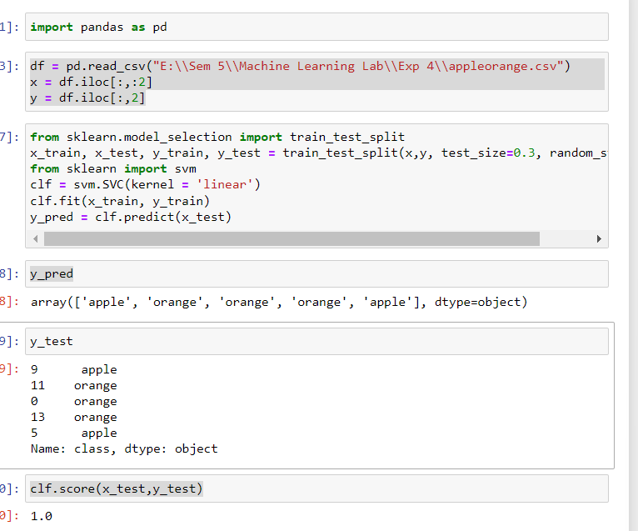

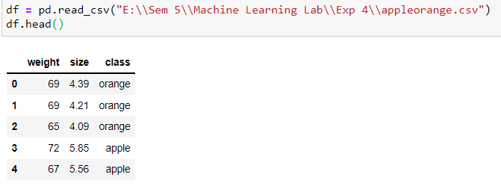

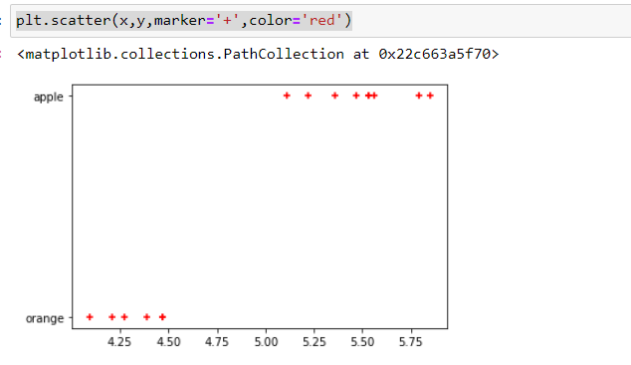

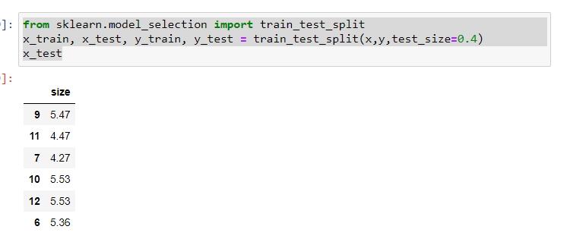

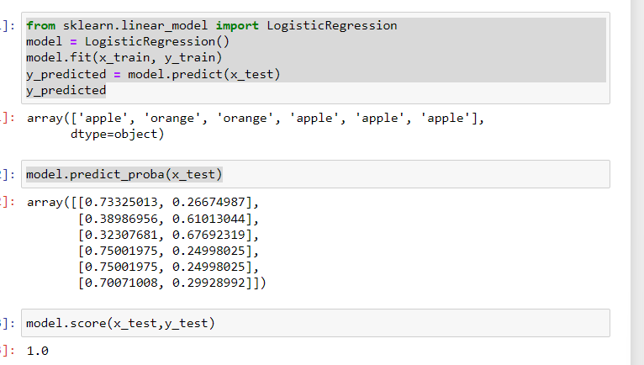

**Learning outcomes:**

1. Understood implementation of SVM (Support vector machine).
2. Learn about analysis using Logistic Regression.

**Evaluation Grid:**

| **Sr. No.** | **Parameters** | **Marks Obtained** | **Maximum Marks** |
| --- | --- | --- | --- |
| **1.** | **Student Performance (Conduct of experiment) objectives/Outcomes.** |  | **12** |
| **2.** | **Viva Voce** |  | **10** |
| **3.** | **Submission of Work Sheet (Record)** |  | **8** |
|  | **Total** |  | **30** |